

MakeUofT 2026

Participant Package

Feb 14th, 2026 - Feb 15th, 2026

Welcome Aboard!
This package will provide preliminary information to MakeUofT 2026 participants. It will cover the logistics of the event in addition to what participants can expect to get out of it.

General Guidelines
IEEE UofT Student Branch is the organization hosting MakeUofT, and we believe in the creativity of our participants. MakeUofT is a 24-hour, 300-maker, open design challenge with the theme of Valentine’s Day, Audio/Music, and Survival(D-Day)! Teams will have the freedom to design and implement whatever they want, from innovative solutions for everyday issues to novel gadgets that push the boundaries of existing designs. You are welcome to bring your own hardware components, or you may use those provided by us.

Each team will be submitting to the Best Overall prize category (1st, 2nd, 3rd place prizes) through Devpost. Additionally, each team can choose to submit to additional prize categories also found on Devpost. During the showcase, each group will have around 5 minutes to present and demo their project. Participants are welcome to view other teams’ demos outside of their own presentation time.

For determining overall 1st, 2nd, and 3rd place, your team’s final design will be evaluated based on the following categories: Idea Originality, Technical Complexity, Working Demonstration and Presentation. Check out Devpost for more info.

Additional Resources
3D printing will be managed by MakeUofT staff to maximize efficiency and fairness. In most cases, printing will be standardized at 0.2 mm layer height using PLA. One person from each team must attend the 3D printing workshop in order to submit a print.

Event Details

Date: Saturday, Feb 14th, 2026 to Sunday, Feb 15th, 2026

Time: Feb 14: 8:30AM (Registration Begins)

Feb 15: 4:00PM (Closing Ceremonies End)

Location: Myhal Centre for Engineering, 55 St. George St, Toronto, ON M5S 0C9 (shown in orange)

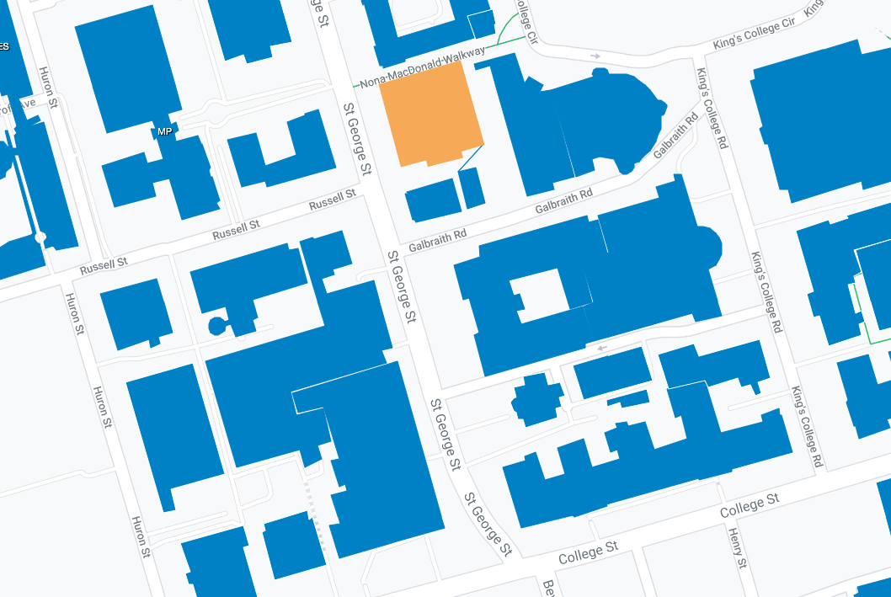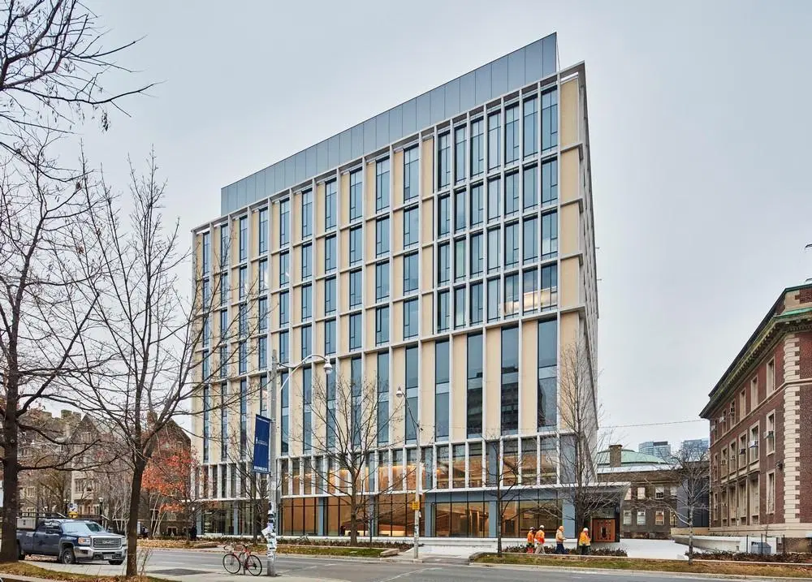

Getting Here

Public Transit
The closest subway stop is Queen’s Park Station (Exit to University of Toronto). Streetcars also run along College Street and Spadina Avenue.

Parking
There are no free parking spots available. Click on the link to see available locations and fees for on-campus parking.

You can click on the parking lot address to get more information about their parking fares, time availability and other restrictions. For more information, refer to the Parking FAQ webpage.

Event Schedule

Date | Time | Event | Location
Saturday, February 14th | 8:30am | Registration and Team Formation | MY Lobby
 | 9:00am | Opening Ceremony | MY 150
 | 10:00am | Hacking Starts!
 | 10:00am | Hardware Component Distribution | MY 320
 | 11:00am | 3D Printing Workshop | MY 330
 | 11:00am | Sponsor Booths Open | MY Lobby
 | 12:00pm | Lunch | MY Lobby
 | 1:00pm | Mentorship Room Opens | MY 380
 | 1:00pm | Titan Haptics Workshop | MY 330
 | 2:00pm | MLH Workshop | MY 330
 | 6:00pm | 3D printing submissions closes
 | 6:00pm | Dinner | MY Lobby
 | 8:00pm | Hardware room closes for Saturday (Orders after 9PM can be picked up on Sunday at 7AM) | MY 320
 | 8:00pm | MLH Mini-Activity: Cup Stacking | MY Lobby
 | 11:00pm | TBD Night Activity | MY 150
Sunday, February 15th | 7:00am | Hardware room opens for Sunday | MY 320
 | 8:00am | Breakfast | MY Lobby
 | 9:00am | Hardware room closes for Sunday | MY 320
 | 10:00am | Hacking Ends!
 | 11:00am | Lunch | MY Lobby
 | 12:00pm | Judging Starts | MY 150
 | 3:00pm | Closing Ceremony | MY 150

*MY = Myhal Centre for Engineering, 55 St. George St, Toronto, ON M5S 1A4
**Schedule tentative to changes in location. Participants will be notified of any changes via Discord.

Makeathon Rules
General Rules
- Attending MakeUofT 2026 gives organizers the right to take photos and videos (that may include yourself or your physical and/or intellectual property) throughout the event, and edit and disperse them as they deem appropriate.
- All participants are required to work in teams of 2-4 due to finite hardware.
- If you are not present by 10:00 am, your spot may be given to participants on the waitlist. Let us know through email ASAP if you will be arriving late.
- Participants will have 24 hours to build a physical project of their choosing (provided it involves hardware of some sort).
- Working or purchasing items in the Myhal Fabrication Facility (MyFab) is prohibited by hackathon participants.

What to Bring
- Any personal hardware or components you may need, aside from a pre-assembled project.
- Your laptop to program the hardware and view documents such as the competition package and datasheets. Along with your chargers.
- At least one team member must provide a government-issued photo ID to check out components.
- A reusable water bottle - we’ll have water fountains at our event venue for you to use!

Rules about Signing Out Components
- Components can be signed out at MY320 using a government-issued photo and student IDs. Larger components must be returned to us before the end of the event.
- Immediately report to organizers if something is wrong with the equipment.

Rules about Pre-Trained Machine Learning Models
- If you are using your own model you trained before the event started, you must indicate so on your Devpost and during judging.
- You must make the model open source before the event and link it on your Devpost, otherwise, your hack will be disqualified.

Credit System
At the start of the competition, each team is allocated 300 credits. Every component available for use is assigned a specific value, and teams can strategically rent the parts they need by spending their credits. To earn additional credits, teams have the opportunity to participate in exciting events and challenges. If you run out of credits you can reach out to June Lin. or Mac Thitiwut Pattanasuttinont (Tech Team Directors) in room MY320 (HSS signout) to discuss your options. However, credit grants are not guaranteed, so plan your spending wisely.

Range of Credit Values:
MCUs: ~100 credits
Peripherals: ~20-25 credits
Dongles: ~5 credits

Component Distribution
Component Distribution will be conducted using our Hardware Signout Site (HSS).
- Component distribution will begin immediately after opening ceremonies in MY320
- Government-issued photo ID will be required to sign out components, and all components must be returned by the end of the event
- You can see and check out components through https://hardware.makeuoft.ca
- Certain hardware models may not match the photos on HSS as we have multiple variants (from different vendors)
- You can sign out hardware in multiple rounds
- You cannot sign out hardware once the hardware room is closed (orders will be received but they will be processed once the room opens back up)

3D Printing
3D Printing will be offered on a first come, first serve basis at MakeUofT. Any team that wishes to submit a print MUST attend the 3D Printing workshop at 11am, no exceptions. Submission will open promptly after the workshop at 11:30am and close at 6pm on Saturday. Submission may reopen if there is capacity and conversely, submission may close early if capacity is reached.

General Rules
Prints will be done in PLA on the Bambu Lab A1 Mini. Below are the following rules associated with 3D printing:

- Prints must be no more than 5 hours in length, calculated with the the settings in next section
- Any support required in the print is included in the print time
- Prints must not be larger than 18cm x 18cm x 18cm
- Prints must be submitted using a form posted on Saturday morning on the discord server
  - There is no guarantee your print will be processed or completed based on printer capacity. A dashboard of the queue will be posted to the discord server on Saturday as reference
  - Teams with prints that are rejected will be notified with the reason. Appealing rejections are not permitted. Resubmission without addressing the reason for rejection will result in loss of printing privileges.
- Prints must be submitted as either .3mf or .stl files
  - We will not rescale prints, we will print as is
- 3D printing will be part of the credit system, and the corresponding item must be ordered on the HSS website - more on this below
- Prints will be distributed in MY320

3D Printing Time Estimation
3D prints will be sliced with Bambu Studio using the following settings:
- Printer: Bambu Lab A1 mini
- 0.28mm Extra Draft @BBL A1M
- Nozzle
  - Diameter: 0.4
  - Flow: Standard
- Project Filaments: Generic PLA
- Process: 0.28mm Extra Draft @BBL AIM
- Support: Enable support - normal (auto)

In the example below, the estimated printing time is 37m10s.
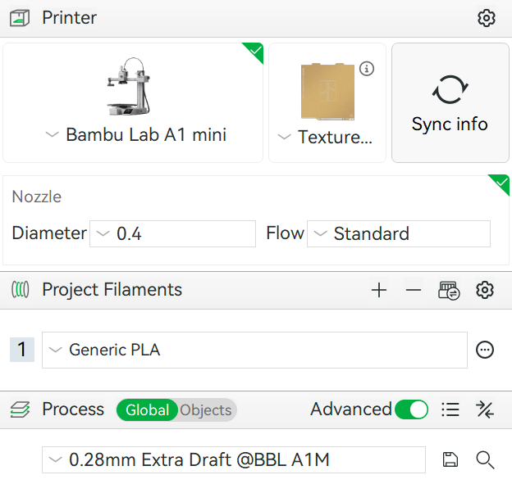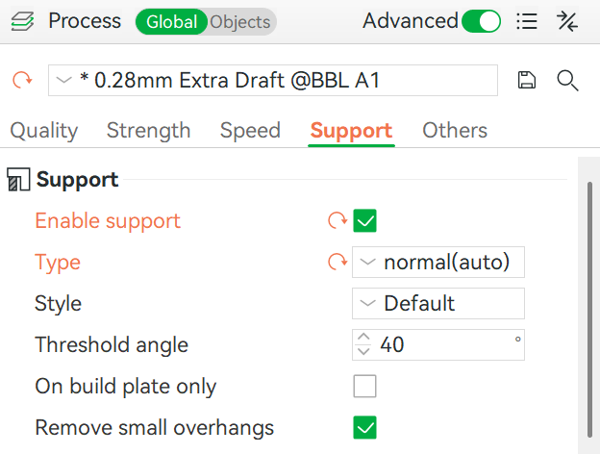
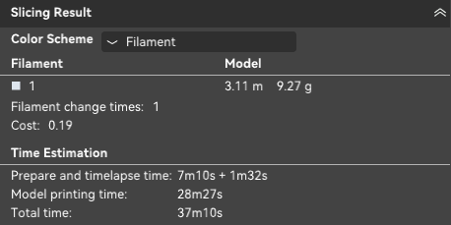

Note that you will not need to provide us with the G-Code. A member of our team will check your submission to ensure that the time you provide for your print is accurate.

Credit System
3D printing will be part of the credit system. The corresponding values are shown below:

Print Time | Value
0-1 hours | 10 credits
1-2 hours | 15 credits
2-3 hours | 20 credits
3-4 hours | 30 credits
4-5 hours | 60 credits

You must order the corresponding 3D printing item in the Hardware Signout Site as well as through the posted submission form for your 3D print to be successfully processed. If you submit a print without ordering the corresponding item in HSS, your print submission will be rejected.

Fabrication Space
This year, a fabrication space for hackathon participants will be available in a section of the Myhal Arena, located in the basement of Myhal. The following tools will be available (not an exhaustive list):

- Jigsaw
- Drills
- Hot glue guns
- Screwdrivers
- Hammers
- Soldering irons
- Utility Knives
- Scissors

Some materials (i.e. wood, cardboard) and hardware (i.e. screws, nails) will be provided, but we cannot guarantee their availability (first come first serve). Participants are welcome to bring their own building materials.

Any hackathon participants wishing to use the Fabrication Space must fill out this waiver form: 2026 MakeUofT Fabrication Space Waiver. Access to the Fabrication Space will be denied without completion of this form.

The Fabrication Space will be open from 11am to 11pm on Saturday, and 7am to 10am on Sunday. Hours are subject to change based on staffing availability.

Room Allocation
Room | Location
Opening/Closing Ceremonies | MY 150
Showcase and Judging | MY 150
Participant Workspaces | MY 150
Component Distribution | MY 320
Mentor Room | MY 380
Workshop Room | MY 330
Fabrication Space | Myhal Arena (basement)

Discord
Join our Discord! This will be our main form of communication to all participants during the makeathon. Sign up using this invitation link.

Wifi
Log into the eduroam Wi-Fi with your school credentials, this should be available for all major universities, domestic and foreign.

Username: <your school username>@<your school domain>.ca (for Canadian universities)
Password: <same as your school’s password>
If you do not go to a university or if you are having trouble connecting to the wifi, please contact hackathon directors for wifi.

Food
Saturday, February 14th
Lunch: Scotty Bons Sandwiches (all meats are Halal)
- BBQ Chicken
- Veggie
- Gluten-free, Lactose-free Options Available
Dinner: Tahini’s Shawarma (all meats Halal)
- Chicken Wrap
- Falafel Wrap
- Gluten-free, Lactose-free Options Available

Sunday, February 15th
Breakfast: Assortment of pastries, cookies and croissants
Lunch: Papa CEO Pizza (all meats are Halal)
- Margherita
- Chicken
- Pepperoni
- Veggie
- Cheese
- Gluten-free, Lactose-free Options Available

Important Notes
If you have a specific dietary restriction, please ask MakeUofT staff about ingredients and bring appropriate medical aid. If food is unavailable for your requirements, we will source and pay for accommodating food. At check-in you will receive a wristband according to your dietary restrictions. Announcements will be made on Discord once food and snacks are served.

Emergency Procedures
If you have any medical (or similar) emergencies, contact an organizer or volunteer for help. We have a first aid kit on standby and can assist you if you message the #firstaid channel on Slack.

Important Links
MakeUofT Resources
- MakeUofT Official Website
- Invitation to MakeUofT Discord Channel
- MakeUofT Devpost
- Hardware/Mechanical Inventory List (will be updated up to the event)

General Electronics Aid
- Datasheets: alldatasheet.com
- Tutorials: electronics-tutorials.ws
- Schematics: electroschALLDATASHEET.COMematics.com

Nearby Stores
- Home Hardware: https://www.homehardware.ca/en/store/13817
- Canadian Tire: https://www.canadiantire.ca/en/store-details/on/toronto-eaton-centre-on-600.html

Sponsors














